CPU SCHEDULING – fcfs.c
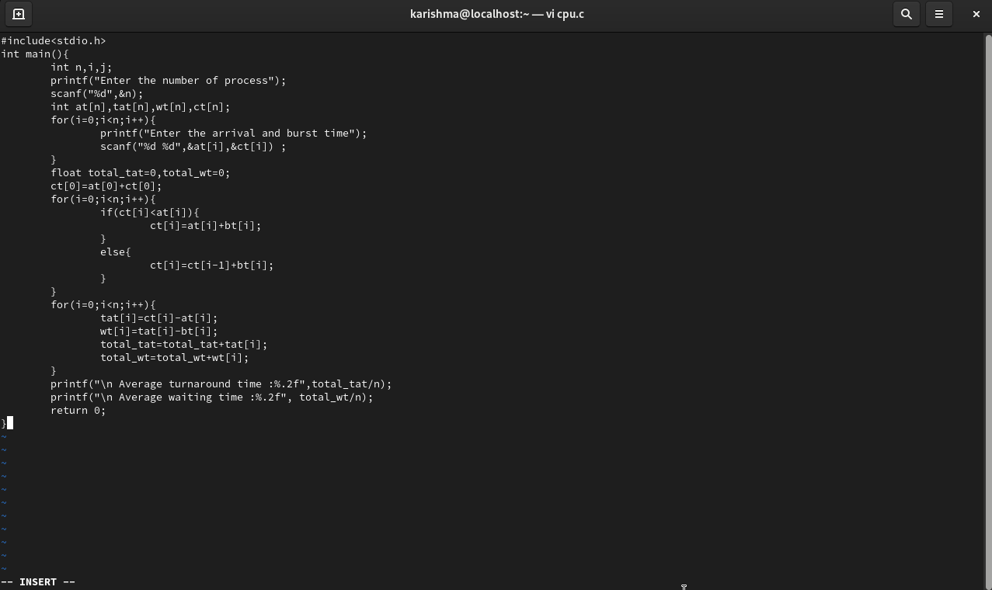

OUTPUT:
